Creating great blogs

Content
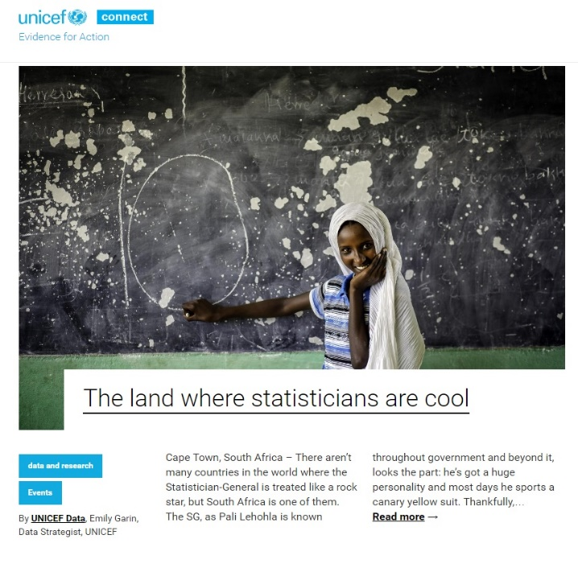
Great content is
- Passionate
- Powerful
- Shares solutions
- Solves a problem
- Fills a need
- Achieves something

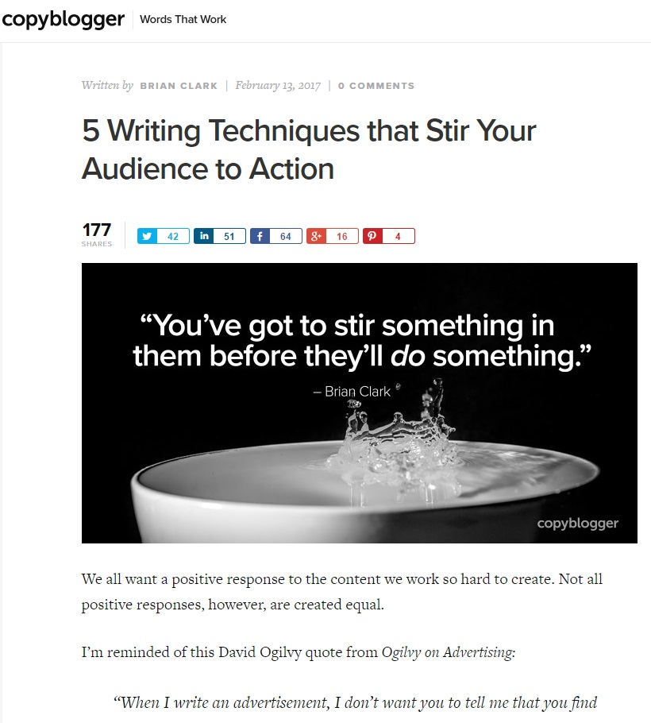

Beyond Subject matter
Great blogs:
- Vary length
- Aggregate content
- Are predictable, reliable
- Visual
- Interactive
- Talks to audience

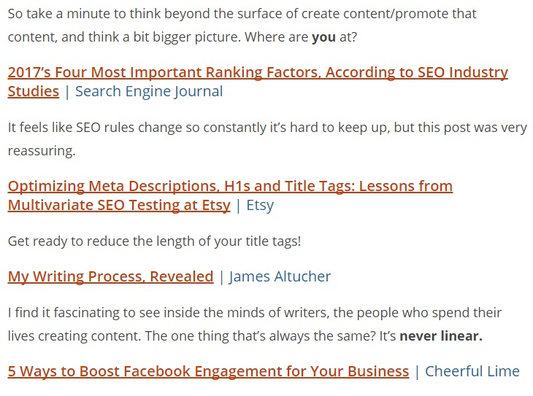
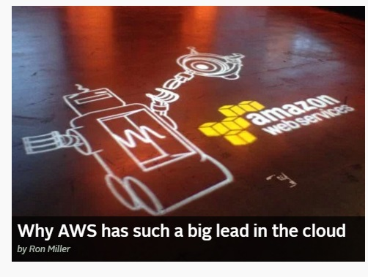

Great headlines
Great headlines:
- 6-9 words
- How, what, why, how many
- Taps curiosity
- Connects with readers
- Contains key words
